Chapter 9: Testing in a Controlled Environment

# Mini Abstract

1-2 paragraph chapter description. Should generally go over contents, expectations, and results. Abstracts are usually the last part of something to be written out since it is a summary of the article, but we can use them here to help flesh out our ideas a bit for how to structure. Final abstract should be overhauled at the end of the chapter though, the chapter dictates the abstract, not the other way around.

Testing in a controlled environment was unable to be completed due to errors in the handling of the drone and equipment. Two flight tests were attempted but both of them failed before flight time data could be gained. Further tests could not be done due to shipping delays when ordering new lift bags. The process that was partially done and would have been followed if the flight test were able to be done is described in the following chapter. STR 8.0.0, Helium Leakage, and STR 10.0.0, Noise Level, were both tested and verified to not be met by the system. STR 1.2.0, Effective Weight, was also verified to not be met due to manufacturing errors.

# 

# Chapter 9

Testing in a controlled environment was unable to be completed due to errors in the handling of the drone and equipment. Two flight tests were attempted but both of them failed before flight time data could be gained. Further tests could not be done due to shipping delays when ordering new lift bags. Procedure for completed, attempted, and planned controlled environment testing are introduced and discussed in this chapter. STR 8.0.0, Helium Leakage, STR 10.0.0, Noise Level, and STR 1.2.0, Effective Weight, all tested but failed to meet their requirements. STR 1.0.0, was not able to be verified due to flight test failures.

## 9.1 Tests to Conduct

In this section we will introduce each of the tests we planned to perform in a controlled environment. This included noise testing, helium loss testing, system weight testing, and flight time testing. It also introduces additional tests that would have been performed in a controlled environment if the control system had been completed and verified in VREP.

9.1.1 Conducted Tests

The first test that was planned to be conducted was a noise level test. This was in order to determine if the system met STR 10.0.0, Noise level, this test would take measurements of the dB level at 5 feet away around the drone in order to determine if the noise level was under 65dB at max throttle.

The next test we planned to conduct was the system weight test to determine if our system met STR 1.2.0, Weight, this test would simply measure the weight of the system when fully inflated with helium in order to determine if the effective weight was within the required 0-5N range.

A helium loss test was to be performed In order to determine if our system met STR 8.0.0, Helium Loss. This test would measure the weight of the system when filled with helium at several time intervals in order to determine if the loss rate of the helium would be less than 10% within a week.

The final test to be performed was a flight time hover test. This was in order to test if our system would meet our STR 1.0.0, Flight Time, stretch goal. This test would have the drone system hover until the voltage alarm sounded, determining the flight time of our system when hovering. This would determine if our power draw analysis seen in Chapter 7 was accurate, as well as determine if our system met the 1 hour hover time stretch goal. This test could not be completed due to fabrication errors. For more information about the fabrication errors see section 3.3.3.

9.1.2 Unconducted Tests

Some additional tests that were planned to be performed but were not able to be done due to parts of the system being incomplete.

First a flight time test at maximum motor throttle to determine if the STR 1.0.0, Flight Time, primary goal of 30 minute flight time would be reached while satisfying STR 2.0.0, Drone Speed. This would function similarly to the hover test except a fan would be used to generate a 20mpg wind, until the voltage alarm sounded. This test would have our system “flying” with a 20 mph airspeed. If the system can maintain its position for 30 minutes, both requirements are met.

A closed loop control flight test would be conducted in order to determine if STR 3.0.0, Remote Control, was met. This would have our system fly using our closed loop control system, it would determine if our system was successfully able to maintain stable pitch and roll angles within ±0.1 radians, while maintaining a stable height of 1±0.15m. additional test could be conducted in wind in order to test its stability in harsher conditions.

An Autonomous controlled flight test would determine if STR 4.0.0, Autonomous Control, was met. This would test the miscellaneous auto take off and landing functions, as well as its ability to fly between waypoints. Additional tests could be conducted in wind and with obstacles to test its stability and collision avoidance.

A Magnetometer interference test would determine if our STR 6.0.0, Interference, was met. This test would take data with the magnetometer with the drone off, on and in various stages of flight in order to determine if the interference created by our system at any stage become greater than 10nT.

## 9.2 Procedures and Results

This section will talk about the procedures of both conducted and proposed tests. For the conducted tests the errors and adjustments that were made will be discussed. The results will also be introduced and analysed.

### 

9.2.1 Noise Testing

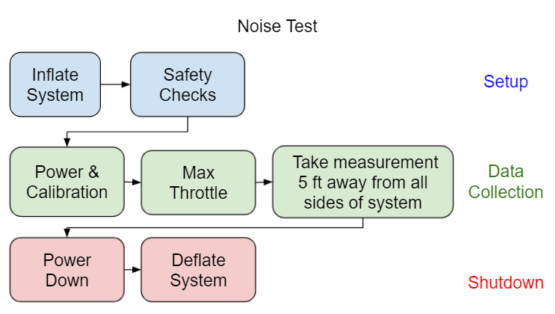

Fig. 9.1. Procedure of Noise Test

The first Controlled environment test that was conducted was the noise test. This test was to determine if the noise level at 5 feet away from the drone was less than 65dB as required by STR10.0.0, Noise level This test was done in the week of 5/17/21 by Dylan Harutoonian, Jeremy Germenis, and Leonid Shuster inside Leonid’s garage. A high level procedure can be seen in Figure 9.1.

Noise level test detailed procedure:

1. Layout envelope so that all motor brackets are on the outskirts and the envelope is flat on that ground, leaving the gondola bracket in the middle of the envelope covered by the top
2. Inflate the system entirely with air until the motor brackets are held taught
3. Perform safety checks
   1. Assure that all motor and signal wires are attached in the gondola and to the motors
   2. Ensure that motor wires will not be hit by the propellers by using zip ties and electric tape to secure the wires to the brackets and envelope.
4. Perform the calibration of motors
   1. If ESCs are uncalibrated
      1. Set the throttle curve on controller to max at 100%
      2. Push the throttle to 100% with the system off
      3. Turn the system on
      4. Wait for 2 beeps followed by third beep from each of the motors
      5. Turn the throttle to 0% within 2 seconds
      6. Wait for 3 more beeps from the motors
      7. Set throttle curve to max allowed throttle at 29% with replacement motors
   2. If ESCs are calibrated
      1. Turn the power on
5. Run the motors increasing the throttle 1% every 2 seconds until 29% is reached
6. Have a member stand 5 feet away from the drone, measured with a 5ft tape measure, and observe the decibel meter on an apple watch while slowly walking along the radius of 5 feet away from the drone
7. Record the highest decibel seen on the watch
8. Turn the motors to zero throttle and turn the power switch off
9. Deflate the system

These procedures were followed and several iterations of the test were done, Figure 9.2 shows one of these tests being conducted. The data in these tests were collected using the on board noise level meter in a Series 6 Apple Watch, according to third party testing the on board noise level meter has an accuracy of 1%[56].

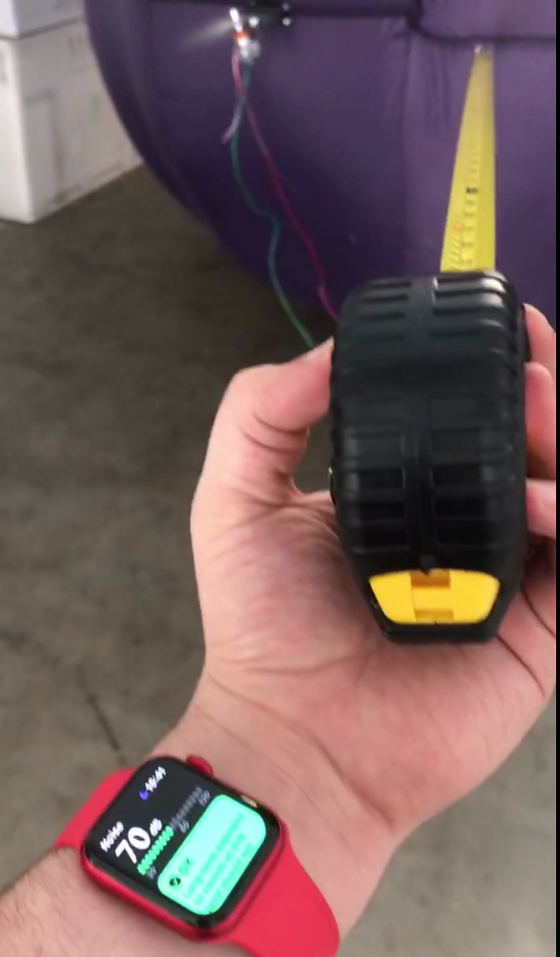

Fig. 9.2. Noise Test Being Conducted.

The test was conducted first with the garage door closed. The result of the test was that the highest decibel rating had a peak of 76dB at the highest motor throttle. However, the test was done again with the garage door open due to the possibility of constructive noise interference. With the garage door open, the highest decibel rating had a peak of 72dB at the highest motor throttle. Both of these tests were conducted several times with consistent results. This verifies that we did not meet STR 10.0.0, Noise Level, which stated the drone should be quieter than 65dB. However, we wish to conduct the same test in an outdoor environment, since the noise level is lower with the garage open it is expected to be even lower when the system is fully outside. This is important as the system is intended to be operated primarily outside once complete. We believe that a noise test outside could meet STR10.0.0, Noise Level, but the test would have to be conducted in order to confirm this. Additionally, it can be noted that the noise level was below 85dB, which is the noise level at which chronic hearing damage starts to occur[76]. Although this does not impact STR 10.0.0, Noise Level, this does have an effect on STR 7.0.0, Drone Safety. For more information about Drone Safety, see Chapter 11.

9.2.2 Helium Loss and Weight testing

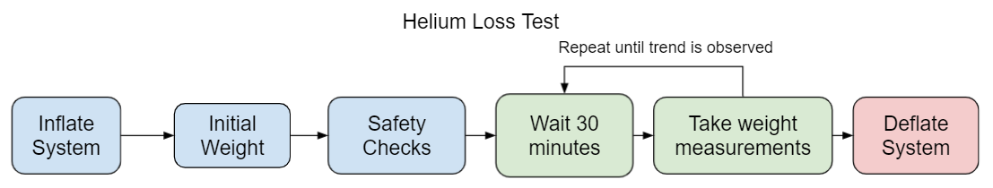

Fig. 9.3. Procedures of Helium Loss Test.

The next controlled environment test was helium loss and system weight. These were conducted at Westside Research Park under supervision of graduate student Gordon Keller. These tests were performed by Dylan Harutoonian and Jeremy Germenis during the week of 5/24/21. The tests were conducted simultaneously with the attempted Flight Time test discussed in section 9.2.3. The goal of the weight test was to verify STR 1.2.0, Weight, while the goal of the helium loss test was to verify STR 8.0.0, Helium Loss First, the drone system had to be transported to the location with the motors and gondola that will be used to hover. A helium tank then had to be bought and delivered from Praxair in Watsonville, CA to the testing room with the safety considerations detailed in Chapter 11. This involved securing the helium tank to a metal fastening in the room and ensuring it was locked with a chain. The testing at Westside Research Park was then approved to be conducted. Before inflating the system the weight of all components parts in the tests were weighed. This included a 1kg weight function as the payload for the purposes of this test. The initial weight without helium was estimated to be 4.444kg. After this the test was ready to start. The high level procedure can be seen in Figure 9.3.

Helium Loss Test Detailed Procedure:

1. Layout envelope so that all brackets are on the outskirts.
2. Inflation
   1. Since the envelope is large then anticipated first the lift bag will be inflated until it is sphere with 1.5m diameter or 1.8m3 in volume (for more information on the envelope fabrication error see Chapter 3.)
   2. The rest of of the system will be filled with 4m3 of helium
3. Check weight of system
4. Safety Check
   1. Assure that all attachments are securely
   2. Attach tether to weight on ground
5. Wait for 30 minutes
6. Check weight of system
7. Repeat steps 5 & 6 several times to see if weight loss if linear or exponential
8. Deflate system
9. Find weight difference over time to estimate helium loss for 1 week

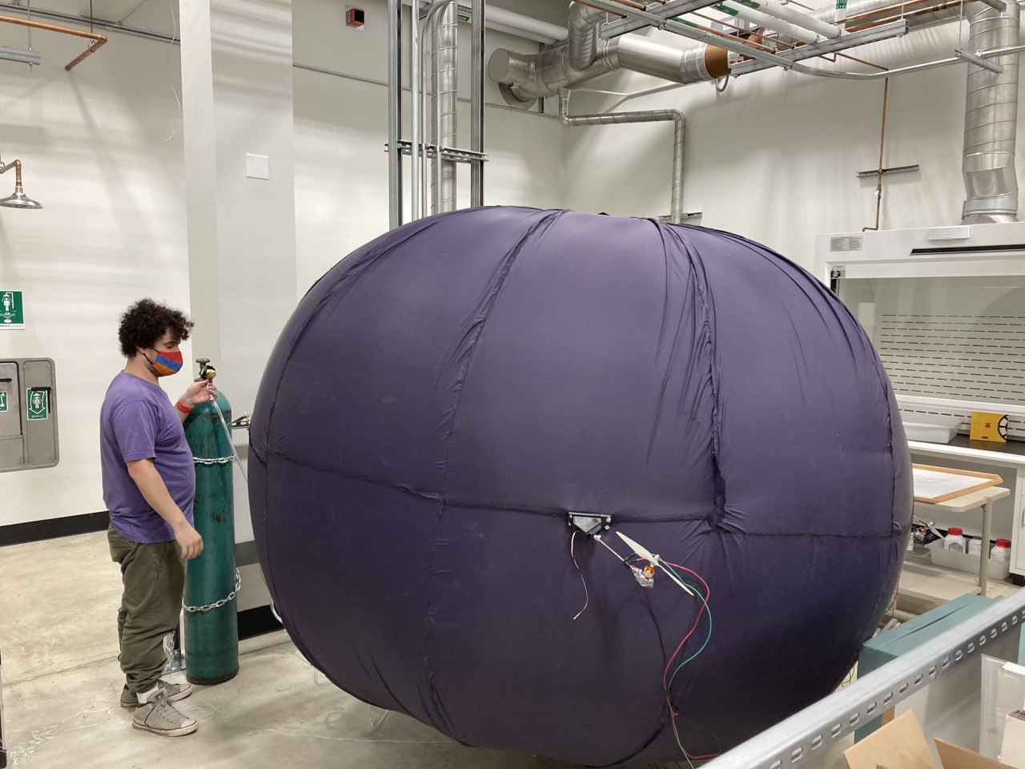

Fig. 9.4. Full System Inflated with Helium

Once the System was fully inflated as seen in Figure 9.4 the system was weighed to be 1.3kg. This was higher than expected and does not meet STR 1.2.0, Weight, this was likely due to too much air being added. The air added additional weight to the system that the helium did not compensate for. Unfortunately the system was punctured during transport to do the hover test discussed in section 9.2.3, so helium loss

A second attempt was made at this test. In this test less air and more helium was to be added, however during the second attempt of the inflation test the inflation hose disconnected from the lift bag. Although the hose was eventually reattached significant helium was lost during the reconnection process. Due to this helium loss we ran out of helium before the system was fully inflated. Additionally when the hose was reattached it was moved inside the envelope and the lift bag was not able to be properly sealed once inflation was finished. However, the data was collected anyway. This time the initial weight of the system was 798g, closer to system STR 1.2.0, Weight, but still not meeting the required <500g. However it is believed that if we had not run out of helium due to the leak during inflation the requirement likely would have been met. 30 minutes later a second data point was taken showing that the system now weighed 960g, As shown in table 9.1 this estimated a loss of 4.2% of the system's helium, meaning that the system would lose 10% of its buoyancy in just over an hour. This verified that we would not meet STR 8.0.0, Helium Loss. The system was once again punctured before any more data could be collected.

Table 9.1

Data Collected in Second Helium Loss Test

| Time | Weight | Estimated helium in system | Percentage of helium lost |
| --- | --- | --- | --- |
| 0min | 798g | 4.50m3 | 0% |
| 30min | 960g | 4.356m3 | 4.2% |

9.2.3 Hovering Flight Time Testing

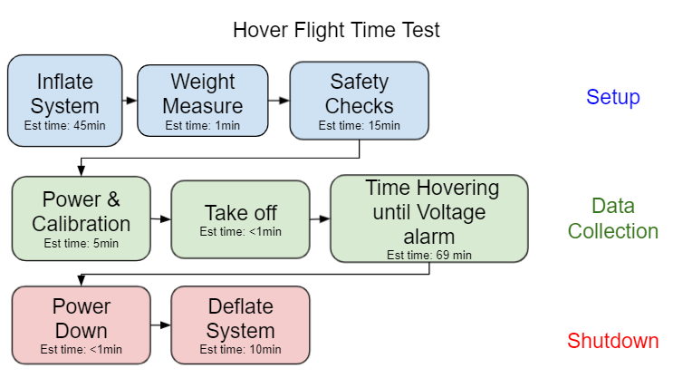

Fig. 9.5. Flowchart of the Hover Test to be Performed in the Westside Research Park Flight Room

The Hovering Flight time test in a controlled environment was done simultaneously, to the weight and helium lost test discussed in section 9.2.2. This test aimed to determine if our system would meet the 1 hour hover flight time stretch goal from STR 1.0.0, Flight Time. The high-level procedure can be seen in Figure 9.5.

Hover Test detailed procedure:

1. Ensure battery is fully charged with 4.2V per cell and 12.6V total
2. Layout envelope so that all motor brackets are on the outskirts and the envelope is flat on that ground, leaving the gondola bracket in the middle of the envelope covered by the top
3. Inflate the system
   1. Since envelope is larger than anticipated first the lift bag will be inflated until it is sphere with 1.5m diameter or 1.8m3 in volume
   2. The rest of of the system will be filled with 4m3 of helium or until lift bag is taught enough so the motor brackets are unable to hit the envelope
4. Check the weight of the inflated system and record the weight in kilograms
5. Perform safety checks
   1. Assure that all motor and signal wires are attached in the gondola and to the motors
      1. Ensure that motor wires will not be hit by the propellers by using zip ties and electric tape to secure the wires to the brackets and envelope.
   2. Attach 2 tether strings to a larger than 10kg weight on ground
6. Perform the calibration of motors
   1. If ESCs are uncalibrated
      1. Set the throttle curve on controller to max at 100%
      2. Push the throttle to 100% with the system off
      3. Turn the system on
      4. Wait for 2 beeps followed by third beep from each of the motors
      5. Turn the throttle to 0% within 2 seconds
      6. Wait for 3 more beeps from the motors
      7. Set throttle curve to max allowed throttle at 29% with replacement motors
   2. If ESCs are calibrated
      1. Turn the power on
7. Perform the flight test
   1. Ensure the servos are turned to upright position
   2. Turn throttle to between 16% and 29% to get system off the ground
   3. Reduce the throttle to 16% for hovering
   4. Keep hovering until voltage alarm sounds
   5. Reduce the throttle to 0%
8. Turn off the power switch
9. Record the amount of time the drone was in the air
10. Deflate the system

The hover test was attempted twice but failed to achieve lift off either time due to mishandling of the equipment.

As stated in section 9.2.2, during the first attempt the system was successfully fully inflated until taut. After this, the safety checks for wiring, attached parts and tether connections were completed. However, when trying to transfer the system from the inflation room into the flight room, the system was punctured due to communication error. Therefore the system was not able to attempt flight during the first test.

The second attempt was done inside the flight room to avoid another transportation accident. We didn’t inflate it there the first time because we were unsure if we could move the helium tank from where it was stored. After we reserved approval to move the helium tank inside the flight room, we started inflating the drone in the netted testing room. However, as stated in section 9.2.2, during inflation, the lift bag entrance was slowly moved up the side of the envelope during inflation. This meant the tube entrance being used to insert the helium was unreachable. After trying to move the lift bag, the tube was taken out of the lift bag and helium leaked as we tried to keep the lift bag closed and move the entrance back towards the opening for the gondola. This loss of helium meant the second inflation was not full enough and the propulsion system mounts were not taut as a result. The significant slack on the propulsion system can be seen in Figure 9.6.

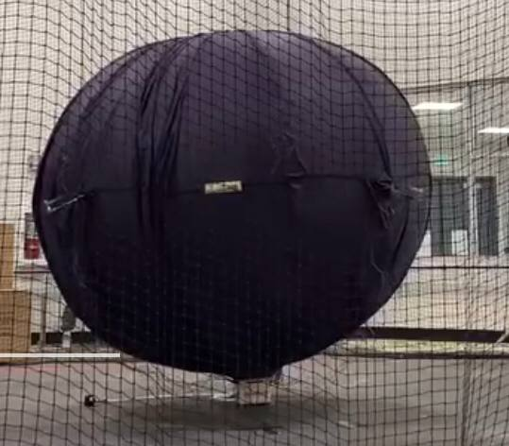

Fig. 9.6. Inflated System with Slack on Hover Test Attempt 2

When we saw that the slack in the system we considered our options. The first option we considered was trying to add more air to the system to make it taut. The benefits of this would be that the motors would be less likely to hit the system due to the slacked envelope not holding them properly outright. However we decided against this as the risk of popping the balloon and not getting any data during this attempted inflation was too great. So after the system was properly tethered, the motors were then turned on and calibrated. However, when approaching 10% throttle, one of the propellers started hitting the envelope. After several attempts to remove the slack from the envelope the test was eventually aborted due to this. We decided to try our first option of adding more air to the lift bag to remove the slack in the envelope but due to the friction of the inflated lift bag inside the envelope the lift bag ruptured and the test was not able to be continued. Therefore, STR 1.0.0, Flight Time, was not verified by thes flight tests.

Although this test was a failure the tests did help us verify our helium safety and inflation techniques. If the helium leak had not caused slack in the envelope the system would have likely been able to hover, however the time of hovering cannot be determined from these results. Power testing, as described in Chapter 7, remained our best flight time estimate while we expected the hover time of the drone to be 69.6 minutes. Another attempt of this test is planned in the future once a new helium lift bag is received.

## 9.3 Unconducted Test Procedures

The proposed procedures for the unconducted tests are shown here. Since these tests were not conducted the errors and results during these tests cannot be discussed.

The procedure for our flight speed test with controlled wind to determine if our system meets STR 2.0.0, Drone Speed, and STR 1.0.0, Flight Time shown in Figure 9.7

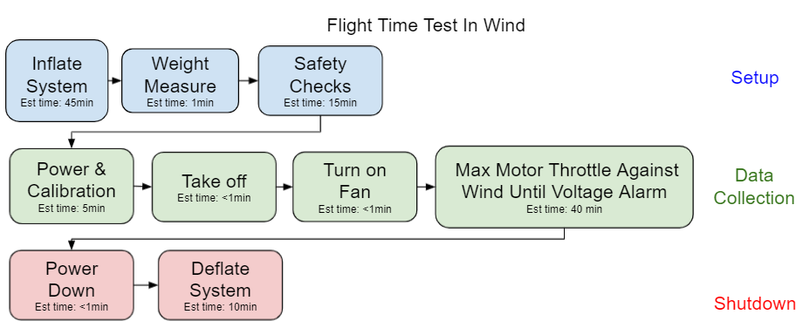

Fig. 9.7. Wind Speed Test

The procedure for the closed Loop control flight test the would be conducted in order to determine if STR 3.0.0, Remote Control, was met is shown in Figure 9.8

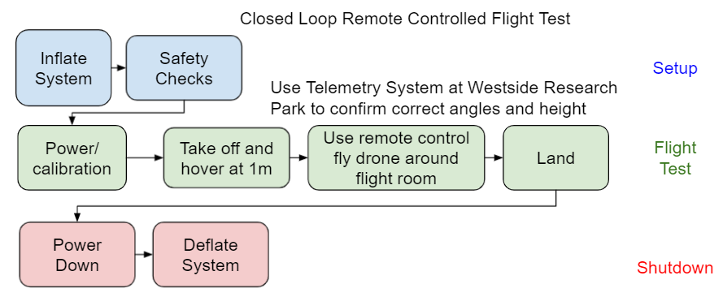

Fig. 9.8. Closed Loop Remote Controlled Flight Test

The procedures for the autonomous controlled flight test that would determine if the STR 4.0.0, Autonomous Control, was met iss shown in Figure 9.9

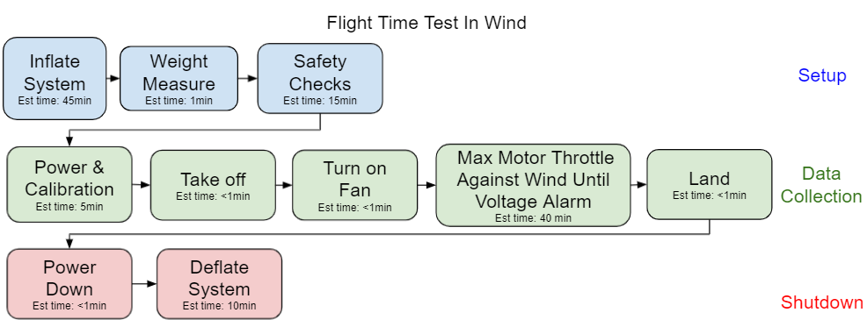

Fig. 9.9. Autonomous Flight Test

Finally the procedures for the magnetometer interference test that would determine if our STR 6.0.0, Interference, was met is shown in Figure 9.10

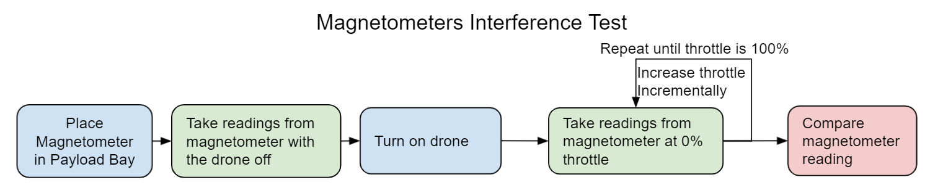

Fig. 9.10. Flow chart of Magnetometer Test procedures

Although these tests have not been conducted we believe that these procedures would effectively verify the requirements once the system is ready for the tests.

## 9.4 Conclusion

Through the controlled tests conducted we were able to verify that our drone did not meet several requirements. First we found that the STR 10.0.0, Noise Level, was not met in an indoor environment. We found that STR 1.2.0, Weight, was not met but likely may have been if the system was fully inflated. We also found that STR 8.0.0, Helium Loss, was not met. Lastly due to the failure of the flight testing, STR 1.0.0, Flight Time, was not able to be verified. Additionally we designed procedures for testing for STR 2.0.0, Drone Speed, STR 3.0.0, Remote Control, and STR 6.0.0, Interference.

# 

# Chapter Bibliography

We do have a full bibliography that should absolutely be updated with all content here. The point of the chapter bibliography is to help keep track of citations in the chapter since the numbering may change in the full bibliography with changes and additions. This way will isolate the sources in this section so you can cite here without having to worry about it, and can use a simple find and replace on your citations to update the new numbering when we combine everything in the final report.

[56]

Hall, Zac, and Zac Hall, “How Accurate Is Apple Watch Noise Level Detection for Hearing Health?” *9to5Mac*, 25 Sept. 2019, 9to5mac.com/2019/09/25/apple-watch-noise-app-accuracy/.

[76]

“What Noises Cause Hearing Loss?” *Centers for Disease Control and Prevention*, Centers for Disease Control and Prevention, 7 Oct. 2019, www.cdc.gov/nceh/hearing_loss/what_noises_cause_hearing_loss.html.